**EKSctl installations:**

Install AWS-cli by following command

curl "https://awscli.amazonaws.com/awscli-exe-linux-x86_64.zip" -o "awscliv2.zip"

unzip awscliv2.zip

sudo ./aws/install

**aws congifgure**

Need to give access id , Secret access key & region

**To install kubectl**

1. Update the apt package index and install packages needed to use the Kubernetes apt repository:

sudo apt-get update

sudo apt-get install -y ca-certificates curl

2. If you use Debian 9 (stretch) or earlier you would also need to install apt-transport-https:

sudo apt-get install -y apt-transport-https

3.Download the Google Cloud public signing key:

sudo curl -fsSLo /etc/apt/keyrings/kubernetes-archive-keyring.gpg https://packages.cloud.google.com/apt/doc/apt-key.gpg

4.Add the Kubernetes apt repository:

echo "deb [signed-by=/etc/apt/keyrings/kubernetes-archive-keyring.gpg] https://apt.kubernetes.io/ kubernetes-xenial main" | sudo tee /etc/apt/sources.list.d/kubernetes.list

5.Update apt package index with the new repository and install kubectl:

sudo apt-get update

sudo apt-get install -y kubectl

(OR)

sudo snap install kubectl –classic

curl -LO <https://storage.googleapis.com/kubernetes-release/release/>`curl -s <https://storage.googleapis.com/kubernetes-release/release/stable.txt>`/bin/linux/amd64/kubectl && \  
chmod +x ./kubectl && \  
sudo mv ./kubectl /usr/local/bin/kubectlf

------------------------------------------------------------------------------------------------------------------------------

**To install Eksctl**

**Downloading Eksctl on Ubuntu/Debian**

Download and extract the latest release of eksctl with the following command.

curl --silent --location "https://github.com/weaveworks/eksctl/releases/latest/download/eksctl_$(uname -s)_amd64.tar.gz" | tar xz -C /tmp

Move the extracted binary to /usr/local/bin

sudo mv /tmp/eksctl /usr/local/bin

Test that your installation was successful with the following command.

eksctl version

Generate ssh-keygen by using following command:

ssh-keygen

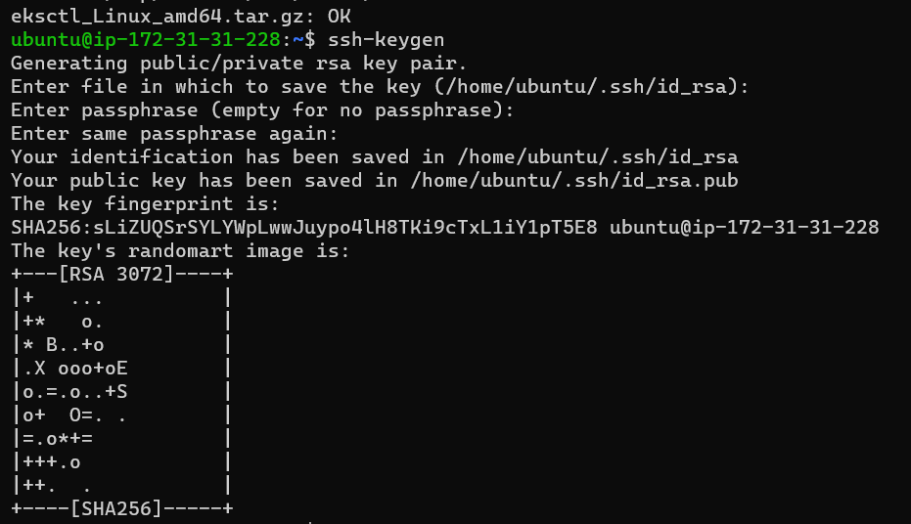

Now use following yaml file to create EKSctl cluster (**cluster.yaml)**

**vi cluster.yaml**

apiVersion: eksctl.io/v1alpha5

kind: ClusterConfig

metadata:

  name: basic-cluster

  region: us-west-2

nodeGroups:

  - name: ng-1

    instanceType: t2.large

    desiredCapacity: 1

    volumeSize: 10

    ssh:

      allow: true # will use ~/.ssh/id_rsa.pub as the default ssh key

To run above yaml file use following command

**eksctl create cluster -f cluster.yaml**

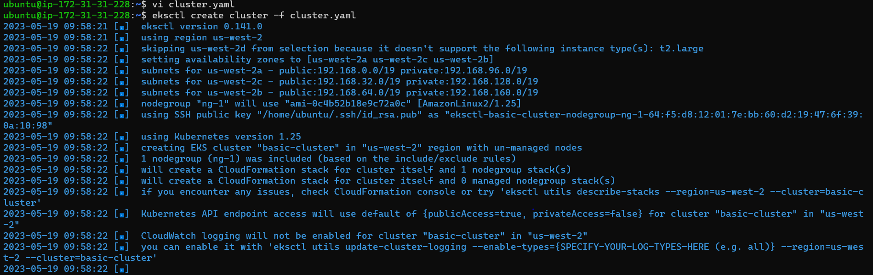

**Now create Namespaces**

**vi namespace.yaml**

---

apiVersion: v1

kind: Namespace

metadata:

  name: dev

---

apiVersion: v1

kind: Namespace

metadata:

  name: qa

---

apiVersion: v1

kind: Namespace

metadata:

  name: uat

---

apiVersion: v1

kind: Namespace

metadata:

  name: test

**docker login**

**give docker login credentials**

docker image pull nginx

**Next push the image to ECR**

aws ecr get-login-password --region us-east-1 | docker login --username AWS --

password-stdin 694448848887.dkr.ecr.us-east-1.amazonaws.com

docker tag nginx:latest 694448848887.dkr.ecr.us-east-1.amazonaws.com/nginx:latest

docker push 694448848887.dkr.ecr.us-east-1.amazonaws.com/nginx:latest

